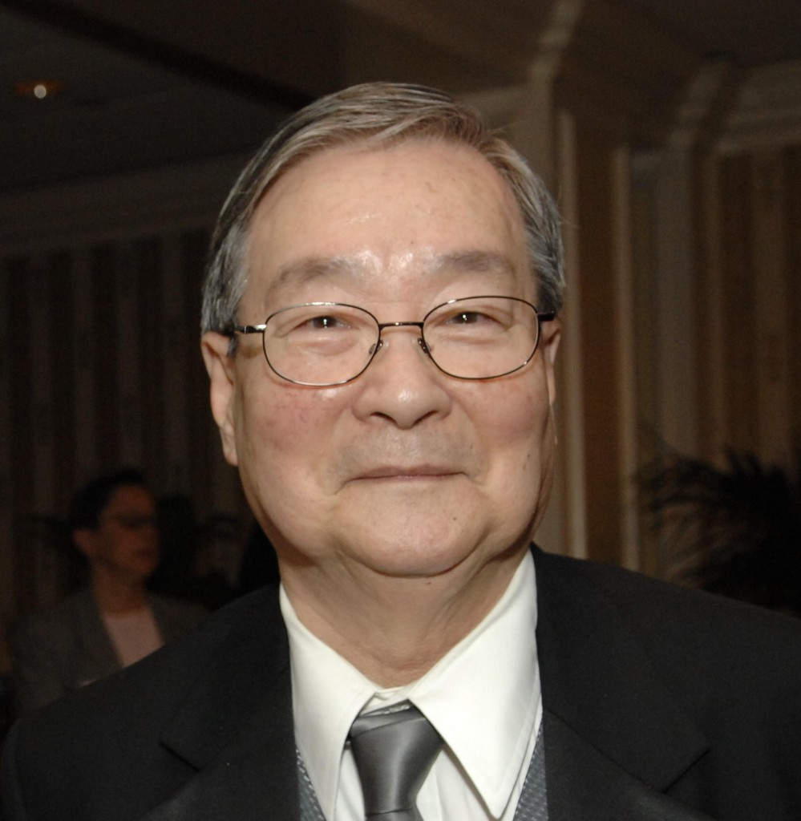

Chi Wang, Ph.D.
President & Chair
U.S.-China Policy Foundation

Dr. Chi Wang has been a Professor of History at Georgetown University since 1969. His areas of expertise include contemporary China and U.S.-China relations. Dr. Wang contributed to the establishment of Georgetown University’s Ph.D. program in Asian History. Since 1972, he has acted as an advisor for graduate students majoring in U.S.-China relations.
Dr. Wang has also been responsible for the development of the Chinese collection at the Library of Congress over the past thirty years. With now over one million volumes, the collection is the largest of its kind outside of China and is America’s most important center on traditional and contemporary China. It is frequently consulted by government agencies, the academic community, and other researchers.
Dr. Wang served as an honorary consultant to the White House relating to U.S.-China trade issues during the Carter Administration and the first Bush administration. He is a longtime member of the National Committee on U.S.-China Relations (NCUSCR). Dr. Wang also served as an honorary consultant to the National Academy of Sciences’ Committee for Scholarly Communication with the People’s Republic of China. Dr. Wang represented the U.S. government in 1972 in negotiations to establish cultural exchange projects with the Chinese government in Beijing.
In 1995, Dr. Wang and a number of prominent American diplomats co-founded the U.S.-China Policy Foundation. Dr. Wang currently serves as the Foundation’s chair and president. He produces China Forum, a weekly talk show on U.S.-China relations broadcast locally on public television since 1990. He is also the founder and publisher of the Washington Journal of Modern China. Dr. Wang is the author of three recently published books: A Compelling Journey from Peking to Washington (Hamilton Books, 2011), George W. Bush and China: Policies, Problems and Partnership (Lexington Books, November 2008) and 從北京到華盛頓: 王冀的中美歷史回憶 (From Beijing to Washington: Witnessing Changing Sino-American History; Commercial Press of Hong Kong, 2008). Dr. Wang received his Ph.D. degree from Georgetown University in 1969.

